Instructions on how to purchase a star skate test ticket. One test ticket must be purchased per test and provided to your coach.
- Go to the www.whitbyfsc.com and go to the registration section:
- Choose purchase products
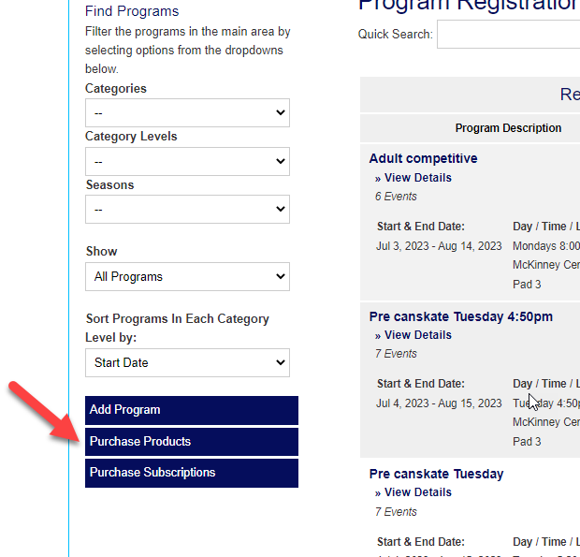

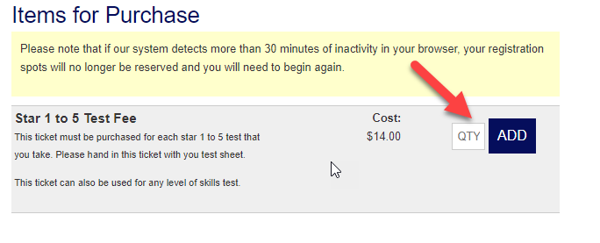

- Add the number of test tickets you skater requires. One test ticket is required for each test each skater takes. This ticket is valid for Star 1 to 5 tests done with you private coach and also valid for any skills test completed by your skaters coach.
- Complete your purchase and print off your ticket to provide to your skaters coach.

